**IBM NALAIYA THIRAN WEEKLY ASSIGNMENT – 4**

**NAME :** N HARINANDINI

**REG NO :** 2019504526

Write code and connections in wokwi for ultrasonic sensor. Whenever distance is less than 100cms send “alert” to ibm cloud and display the device recent events.

**WOKWI IMAGE**

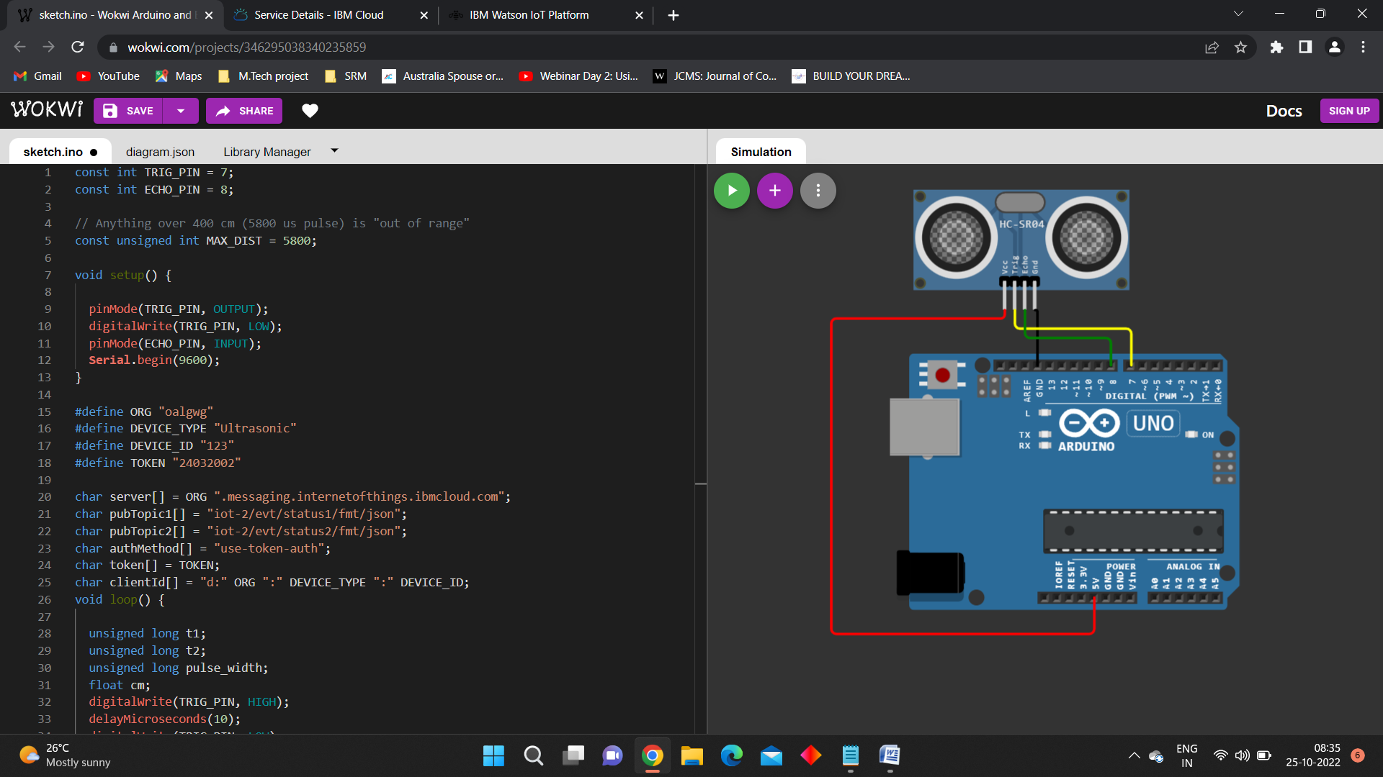

**IMAGE OF IBM WATSON IoT PLATFORM**

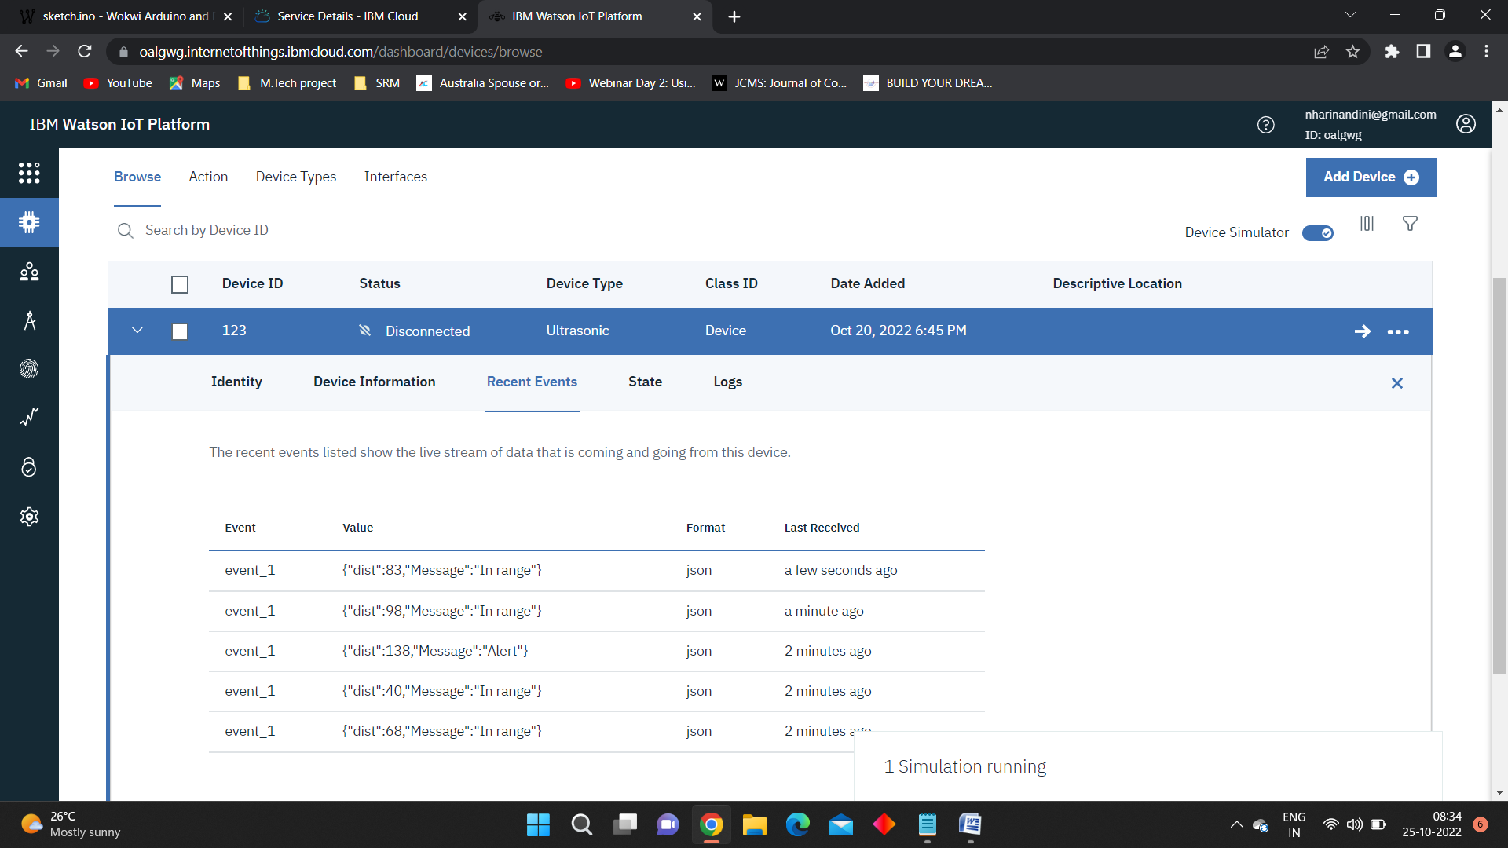

**WOKWI LINK**

https://wokwi.com/projects/346295038340235859